ACCESS TO AFFORDABLE FINANCE PROJECT DOCUMENTATION

Author: Anidu Yakubu Khalid

Project completion date: 15/05/2025

Email: aniduyakubu@gmail.com

# 1. Introduction

## Background

Access to affordable finance is a crucial enabler for economic empowerment, particularly for youth and small-scale agripreneurs in Nigeria. Despite the critical role that financial services play in stimulating economic growth and reducing poverty, many Nigerians face significant barriers due to limited access to formal financial institutions and high credit risk. This project aims to leverage data and technology to measure financial access and credit performance, and ultimately to inspire innovative solutions to expand financial inclusion in Nigeria.

## Purpose

The documentation outlines the project’s scope, objectives, methodology, data sources, analysis, and deliverables. It serves as a guide for project stakeholders including data analysts, developers, and policymakers to understand the problem, work towards solutions, and evaluate the impact of interventions.

# 2. Problem Statement

Agriculture and small-scale entrepreneurial activities are critical to Nigeria’s economy. However, youth participation and productivity are hampered by:

**Limited Access to Finance:** A significant proportion of rural adults and young agripreneurs lack access to formal financial services (as evidenced by low percentages in bank account ownership and loan uptake).

**High Credit Risk:** Many potential borrowers fall under high-risk profiles, making financial institutions reluctant to extend credit, further excluding marginalized groups.

The project investigates these challenges by assessing both the “access score” (indicating financial service availability) and the “credit score” (indicating creditworthiness), thereby highlighting the structural gaps in financial inclusion.

# 3. Project Objectives

The project has three primary objectives:

## 1. Assessment of Financial Access:

* Evaluate the proportion of Nigerian respondents with access to various financial services (bank accounts, mobile money, microfinance, etc.).
* Segment access statistics by demographics (age, household, geographic location, etc.).

## 2. Evaluation of Credit Performance:

* Develop a credit scoring model using proxy indicators (savings behavior, financial health, credit history, and literacy).
* Identify factors that contribute to high credit risk and potential default.

## 3. Actionable Insights and Innovation:

* Create dashboard visualizations and data-driven or predictive models to highlight the gaps and opportunities in affordable finance.
* Inform policymakers, financial institutions, and fintech innovators on where to target interventions.

# 4. Data Sources and Survey Instrument

### 4.1 Data Sources

EFInA Access to Financial Services (A2F) Survey 2023:

This survey provides nationally representative data on financial access, usage, and financial health. Key datasets include individual responses, household weights, and financial product usage. The dataset can be found in this link: <https://a2f.ng/datasets/#licence-2023-Dataset-revised-popup>

#### Supporting Documents:

* Survey Questionnaire (EFInA-A2F-2023-Questionnaire). Link to the questionnaire: <https://a2f.ng/wp-content/uploads/2024/03/EFInA-A2F-2023-Questionnaire-_Final-1-1.pdf>
* Codebook and metadata for variable definitions. Link to the google colab notebook: <https://colab.research.google.com/drive/1jdrQwme7guY1_PWzNffmnay8zAOXHlPI?usp=sharing>

### 4.2 Survey Instrument Overview

The survey instrument covers the following sections:

* **Household Identification & Demographics:** Includes respondent serial numbers, state/region identifiers, age groups etc
* **Financial Access & Product Usage:** Contains one-hot encoded variables for services such as banking (`banked`), mobile money (`mobile_money`), microfinance (`microfinance_bank`), and informal sources.
* **Credit-Related Variables:** Measures credit usage from formal sources (`credit_b`, `credit_f`), informal credit (`credit_inf`), and exclusion (`credit_ff`), along with aggregated profiles (`credit_strand`).
* **Financial Health and Literacy:** Variables like `finhealth_access`, `finhealth_save`, `finhealth_spend`, and `finhealth_resilience` measure financial health. Financial literacy is measured through subcomponents (`finlit_control`, `finlit_choice`, `finlit_planning`, `finlit_knowledge`, `finlit_cap_final` etc).

# 5. Methodology

## 5.1 Data Preparation

#### Data Cleaning:

Handle missing or inconsistent entries. Normalize numerical variables and verify data integrity.

#### Feature Engineering:

* Access Indicator: Create a binary variable (`access_to_finance`) to denote if an individual has access to formal financial services. This represents the target variable in the predictive model.
* Credit Score Calculation: Use proxy features (financial health, literacy, income channels etc) to compute a weighted credit score.

## 5.2 Analysis

### Descriptive Analysis:

* Calculate overall and subgroup statistics (mean, median, quartiles) for access and credit scores.
* Identify demographic patterns (e.g., disparities by region, gender, and age).

### Diagnostic Analysis

* Cross-tabulate financial access with variables like income, education, and employment.
* Use principal component analysis to determine which factors correlate with the target variable.

### Predictive Modeling:

* Develop a model Random Forest model to predict respondent who have access to affordable finance.
* Validate model performance using cross-validation and analyze feature importance.

## 5.3 Visualization & Dashboard Creation

* **Dashboard Filters:** Implement a respondent-level filter using `respondent_serial`.
* **Key metrics:**
* Credit score, wealthscore and access score at the individual respondent’s level.
* Bar charts for individual financial health and literacy profiles.
* **Interactive Elements**: Allow users to select an individual respondent and display a detailed profile, including access status, credit score, financial health indicators, and identified barriers.

# 6. Credit and Access Scoring

## 6.1 Credit Score

The credit score is computed using a weighted aggregation of proxy indicators:

### Components:

* Formal credit use (from banks and microfinance)
* Savings behavior
* Financial health (spend, save, resilience)
* Financial literacy (control, planning, choice, knowledge)
* Income channels through digital financial services

### Thresholds:

* A score above a certain threshold (e.g., 1,100) is considered low credit risk.
* A credit risk percentage above 50% is viewed as high risk.

## 6.2 Access Score

The access score aggregates indicators of financial access (e.g., having a bank account, using mobile money, being served by formal financial institutions) with a threshold (e.g., 600) to determine whether an individual has access to affordable finance.

# 7. Deliverables

## 1. Data Preparation Scripts:

Scripts in Python Google colab notebook (link above, or [see GitHub](https://github.com/AY-Khalid/accessable_finance_hackathon)) that clean, transform, and encode the dataset where necessary.

## 2. Dashboard:

A Microsoft Excel interactive dashboard that allows filtering by respondent and visualizes key indicators (demographics, financial access, credit score, financial literacy, and health).

## 3. Predictive Models:

An access scoring model that predicts users access to affordable finance.

## 4. App prototype:

A prototype application designed to streamline the loan application process by allowing users to apply easily and efficiently. It features an AI-powered eligibility checker that enables users to assess their qualification status before submitting a loan application.

Link to the app prototype: <https://www.figma.com/proto/YIVfxIctgCnWXflPspIRKY/accessible-finance-UI?node-id=84-47&t=54Izil0FIesahRNV-1&scaling=scale-down&content-scaling=fixed&page-id=0%3A1&starting-point-node-id=84%3A47>

## 5. Documentation and Reports:

This Comprehensive documentation that explains the methodology, data sources, analysis techniques, and interpretations.

# 8. Conclusion and Recommendations

This project provides actionable insights into financial inclusion in Nigeria by quantifying both access and credit performance.

## Key Findings:

* Identification of demographic and geographic disparities in financial access.
* A measurable credit score that can guide risk assessment.

## Recommendations:

* Financial institutions should design products tailored for underserved youth and agripreneurs.
* Policymakers should leverage these insights to implement programs that reduce barriers to accessing formal financial services.

# Appendixes

1. 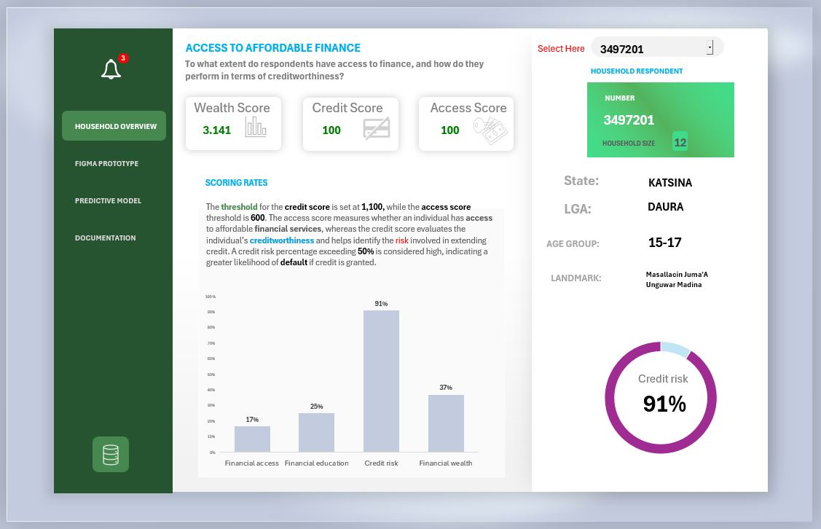**Dashboard**
2. 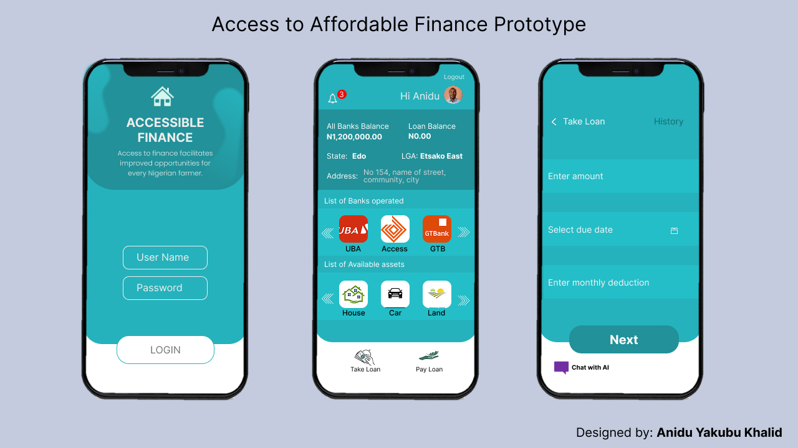**Application prototype**